Sensory Accessibility Guide for
Mr. Burns: A Post-Electric Play
Studio Players

Run-time:
Act I 47:00 minutes
Act II 51:00 minutes
Act III 37:00 minutes

*There will be two 10-minute intermissions (one between each act.)

Mandatory Masking Requirement
Even though proof of vaccination or a negative COVID test is required, all audience members are required to wear a facemask that covers their nose and mouth at any time that they are inside the building. Audience members are invited to step outside during the intermission if they need a “mask break.”

Available Accommodation:
Noise-cancelling Headphones are available for free check-out at the concessions window in the lobby. Ask an usher if you would like to use a pair during the performance. (All headphones are sanitized after each use.)

Ground Plan of the Theatre:

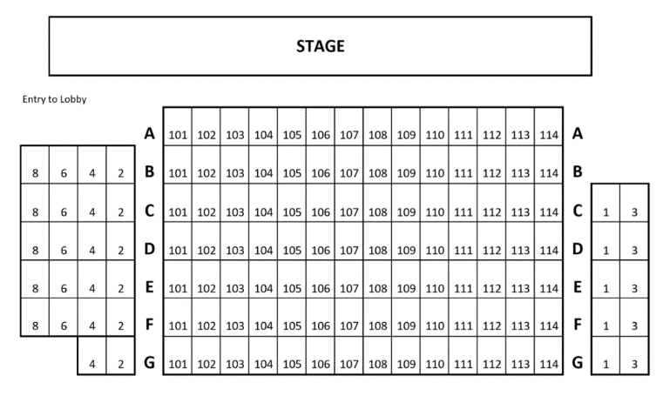

Plot Synopsis:

Mr. Burns: A Post-Electric play is set in three different times using three different forms of theatre to examine the evolution of storytelling and how culture is formed when all is lost. In the first act, five strangers sit around a campfire and try to re-create the “Cape Feare” episode from The Simpsons as accurately as possible. A stranger arrives, and we learn that the characters are living in a post-apocalyptic world after the meltdown of all nuclear power facilities.

In Act II, we find the characters 7 years later as they travel the country performing episodes of The Simpsons to rowdy (and, at times, violent) audiences.

In Act III, we see how the story of the episode has evolved over 75 years as we witness a full-scale musical that is performed almost as a religious rite.

General Sensory Notes:
Identified sensory stimuli include abrupt visual and auditory cues, gunshots, and the smell of stage smoke.

Act III is an epic musical that involves cymbal crashes, yelling, audience applause and yelling (hopefully!), and stage smoke. While we have tried to identify the most abrupt moments, be aware that this musical is written to be a bold sensory experience throughout. Please let us know if you identify any other moments that you feel should be added to this guide. You may email the theatre or mention it to an usher. As this is a digital guide, it can be updated throughout the run, and we are appreciative of any input that you may have.

👂 Gunshots, Loud Practical and Recorded Sounds
Sudden Light Changes, Strobe Effects (for lightning)

Stage Smoke

Breakdown:

Please Note: The cue lines listed are spoken three lines before the identified sensory stimuli.

Act I:
Flash Lights (Throughout the act, actors use flashlights, and while no moment is
directed for the lights to shine on the audience, flashlights may inadvertently shine
in someone’s eyes at moments.)
👂 Abrupt Yelling after Extended Pause: (CUE: Matt says, “… and all of these
pandas run out of Moe’s bar like trailing poker chips.”)

Act II:
👂 Practical Sound: Loud Thunder Drum (CUE: Colleen says, “Side Show Bob,
everyone. Side Show Bob, ah, emerging.”)
👂 Recorded Sound: Gunshot (CUE: Gibson says, “Maria! Maria! You have the key
right?”

Act III:

👂 Practical Sound: Loud Thunder Drum (CUE: Bart says, “Mom! Dad! Lisa! Maggie!
This way!”
Smell: Stage Smoke (Cue: The ensemble starts singing the “Wah, wah” sounds as
Mr. Burns enters through the top of the houseboat.)
👂 Practical Sounds and Lighting: Loud Thunder Drum, Wind, and Strobe-like
Lightning Effects (CUE: The ensemble starts singing the “Wah, wah” sounds as Mr.
Burns enters through the top of the houseboat.)
👂 Practical Sound: Possible Audience Applause and Cheering, Unexpected
Changes in Actor Volume (CUE: Mr. Burns says, “Let me tell you a little story. It is
the story of the Left Hand and the Right Hand…”)
👂 Practical Sound: Loud Gong Strike (CUE: Homer sings, “Just remember, little
Lisa, everything will be alright…”)
Light Cue: Shadow Puppetry Backlight—the window of the boat will be quickly lit
by a bright light. (Cue: Edna sings, “Hate knows every story ends on a dark and
raging river,” and Mr. Burns pulls down the window shade.)
👂 Practical Sounds and Lighting: Loud Thunder Drum, Wind, and Strobe-like
Lightning Effects (CUE: The ensemble sings, “They try to rise, they try to fly. The
wind fills in their wings, they die.”)
👂 Practical Sounds and Lighting (Extended Cue Throughout): Loud Thunder
Drum, Wind, and Strobe-like Lightning Effects (CUE: Mr. Burns says, “Another
second? Another second or two? There is nothing, dear boy, noting another second
can do…”)
👂 Practical Sound: Extended Rolling Thunder (CUE: Bart stabs Mr. Burns, and Mr.
Burns drops his sword.)
Light Cue: A Gradual Build of Very Bright Light (CUE: Bart sings, “The world is full
of everything. I’m a boy who could do anything.” This lasts through the end of the
show.)

