Sensory Accessibility Guide for
Sweat
Studio Players

Approximate Run-time:
Act I 1 hour 10 minutes
Act II 1 hour
*There will be a 15-minute intermission between the two acts.

Mandatory Masking Requirement
All audience members are required to wear a facemask that covers their nose and mouth at any time that they are inside the building. Audience members are invited to step outside during the intermission if they need a “mask break.” Proof of vaccination is not required.

Available Accommodation:
Noise-cancelling Headphones are available for free check-out at the concessions window in the lobby. Ask an usher if you would like to use a pair during the performance. (All headphones are sanitized after each use.)

Ground Plan of the Theatre:

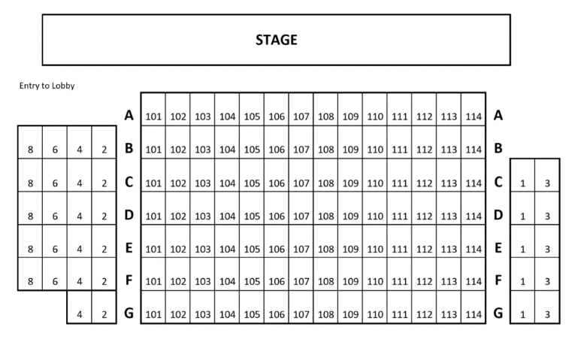

Plot Synopsis:

Filled with warm humor and tremendous heart, Sweat tells the story of a group of friends who have spent their lives sharing drinks, secrets, and laughs while working together on the factory floor. But when layoffs and picket lines begin to chip away at their trust, the friends find themselves pitted against each other in a heart-wrenching fight to stay afloat.

General Sensory Notes:
Identified sensory stimuli include loud yelling and physical violence.

*As this is a digital guide, it can be updated throughout the run of the show. If you notice that we have overlooked a cue that should be included, please tell an usher, and we will update the guide as soon as we are able. We are also open to any other general feedback that you may have in regards to this and future sensory guides. We welcome your insights as we strive to make Studio a welcoming environment for all audience members. Thank you for helping us improve in this capacity.

👂 Loud Yelling
Physical Violence

Breakdown:

Please Note: The cue line listed is spoken a few moments before the yelling begins.

Act I:
Practical Smoking: Odorless stage cigarettes are used in Act I, Scene 5.

Act II:
Practical Smoking: Odorless stage cigarettes are used in Act II, Scene 3.
👂 Practical Sound: Loud Arguing & Physical Violence (CUE: Tracey, “Did you see
the way he looked at you guys? he's eating your dinner, your steak and potatoes...”)

